

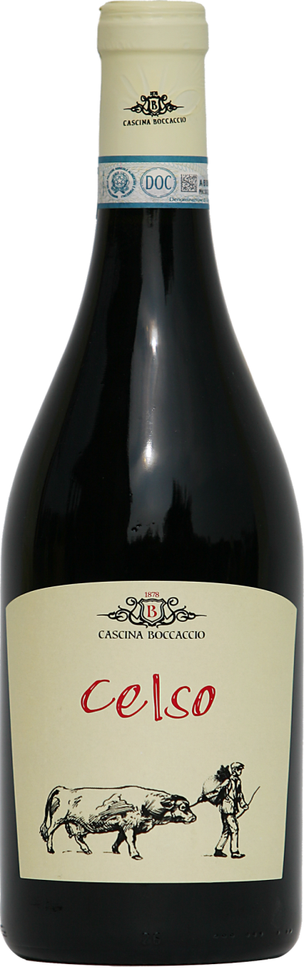 | CELSO  Denomination: Dolcetto di Ovada DOC  Grapes: Dolcetto 100%  Production area: vineyards planted in different period, from 70 to 12 years ago, exposed to the North East at 250 mt a.s.l., situated in Tagliolo Monferrato, Piedmont, Northern Italy.  Soils: clay, chalky turfs  Number of vine stocks per hectare: 4500  Cultivation: Guyot, manual pruning  Yield per hectare: depending on the vintages, 60 to 70 quintal per hectare  Vintage: manual harvest in crates starting in mid-September  Vinification: in thermo-conditioned stainless steel tanks, 7 to 14 days with  pumping and delestage, followed by wine dregs refinement in vitrified cement  barrels.  Refinement in wood barrels: not provided  Service temperature: 16°- 18° C.  Alcohol content: depending on the vintages, 13% or 14% vol.  Available sizes: 0,375 lt -0,75 lt -1,5lt -3,00 lt

Cascina Boccaccio di Roberto Porciello
Loc. Piano Moglia 21 - 15070 Tagliolo Monferrato (AL)
PI 02008460061 - C.F.PRCRRT73M11G197K
Cell: 3477549369 - Fax: 0143882400 - e-mail: viniboccaccio@gmail.com
www.cascinaboccaccio.com

